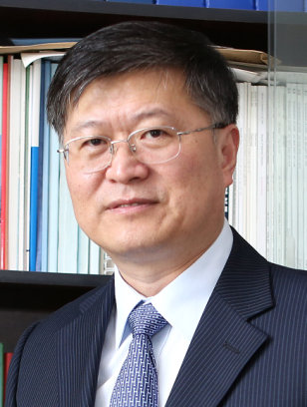
He TIAN is a Professor at East China University of Science & Technology (ECUST) in Shanghai. He obtained his Ph.D. from ECUST in 1989 and was appointed Cheung Kong Distinguished Professor by the Education Ministry of China in 1999. His current research interests include the syntheses of novel functional organic dyes and supramolecular polymers as well as development of interdisciplinary materials science that determines the electronic and optical properties of materials. Prof. Tian has already published over 500 papers in international journals and applied 108 Chinese patents (over 25K total citations, H-index > 86 by Web of Science). He was selected as a member of the Chinese Academy of Science (2011) and a Fellow of TWAS–The World Academy of Sciences –for the advancement of science in developing countries (2013).

