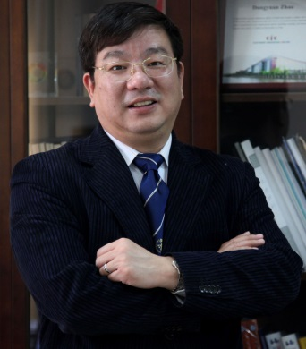
赵东元教授，1963 年出生于沈阳市。1980年考入吉林大学化学系，1984年获得理学学士学位，1987年获吉林大学化学系理学硕士学位。1990年获吉林大学和大连化学物理研究所物理化学专业理学博士学位。1993 ~ 1994年在以色列魏兹曼科学院化学物理系做博士后。1995 ~ 1996年在美国休斯顿大学化学系做博士后。1996 ~ 1998年在美国加州大学圣芭芭拉分校材料系和化学系做博士后。1998年12月复旦大学教授；2000年入选教育部长江“特聘教授”，2007年被增选为中科院院士。2010年被增选为世界科学院（TWAS）院士。
主要从事沸石分子筛、纳米介孔材料合成、结构和在催化、电池、生物、水处理等能源方向应用的研究工作。在国际重要刊物上发表SCI论文600余篇，包括：Nature (2); Science (2); Nature Mater (1); Nature Chem (1); Nature Comm (4); Science Adv (1); J Am Chem Soc (53); Angew. Chem. (31); Adv. Mater. (32)；获中国专利授权39项。论文被引用超过7.6万次（h index = 130）。曾获得2004年度国家自然科学二等奖； 2008年TWAS化学奖；2008年国际介观结构材料协会奖；2009年何梁何利科学进步奖；2013年印度化学会Rao Award，2016年发展中国家科学院科学奖TWAS-Lenovo Science Award。被列为100名全球引用率最高的化学家之一，被汤森路透社列为全球化学、材料两个领域高被引科学家；也被列为最具国际影响力的中国科学家；现任国际介观结构材料协会IMMA主席、国际刊物ACS Central Science编辑。曾任英国皇家化学会Journal of Materials Chemistry主编、Journal of Colloid Interface Science编辑（Co-Editor），任十几种国际重要刊物如：Journal of The American Chemical Society等国际刊物的编委、顾问编委。

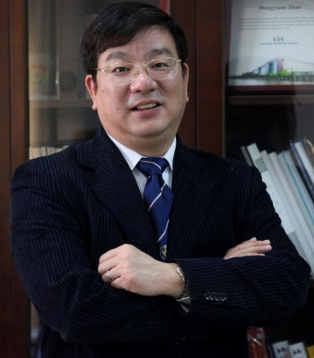
Dongyuan Zhao was born in Northeastern of China, he received B.S. (1984), M.S. (1987) and PhD (1990) from Jilin University. He was a post-doctoral fellow in the Weizmann Institute of Science (1993–94), University of Houston (1995–96), University of California at Santa Barbara (1996–98). Now he is a Professor (Cheung Kong and HaoQing Professorship) in the Department of Chemistry at Fudan University. He was a member of Chinese Academy of Sciences and The Third World Academy of Science (TWAS), Council Member of IZA, President of International Mesostructured Materials Association (IMMA). He has received many awards such as TWAS Lenovo Science Prize (2016); CRN Rao Award from India Chemical Research Society (2013); Muetterties Memory Award (2012); The Ho Leung Ho Lee Award (2009), TWAS Prize (2008); IMMS Award (2008); DuPond Award (2005). He is now appointed as He is now appointed as senior Editor of ACS Central Science; he serviced as Editor-in-Chief of Journal of Materials Chemistry, and co-editor of Journal of Colloid and Interface Science. He published more than 600 peer-review papers, 39 patents and is listed as one of highly cited researchers ISI in both Chemistry and Materials Science fields (Total citation ~ 76,000, h index 130). His research interests mainly include designed synthesis, assembly, structure and application of ordered mesoporous materials.
http://www.mesogroup.fudan.edu.cn

